
NATIONAL UNIVERSITY OF MODERN LANGUAGES
Department of Software Engineering
BSSE 5 (Afternoon) – Lab Final–Fall 2024
Paper: CN Lab  Time Allowed: 3 Hours | Total Marks: 50  Instructor: Dr. Hasan Humayun

Name: _______Zulqarnain hassan
Roll No.: ____________sp21379

Report Submission

Once you conclude the configuration paste the figure(s) in the desired Section, further instructions are in the sections.

Section 1: LANs [20 Marks]

Section 1.1: Switch Running-configuration [3 Marks]

Paste the running-configurations Figure under each section. Show the IP address configured for each VLAN as per Figure 1.

NOTE: Each Switch should have MOTD and Name as defined in Q1 bullet 4.

- Switch 1 Running Config
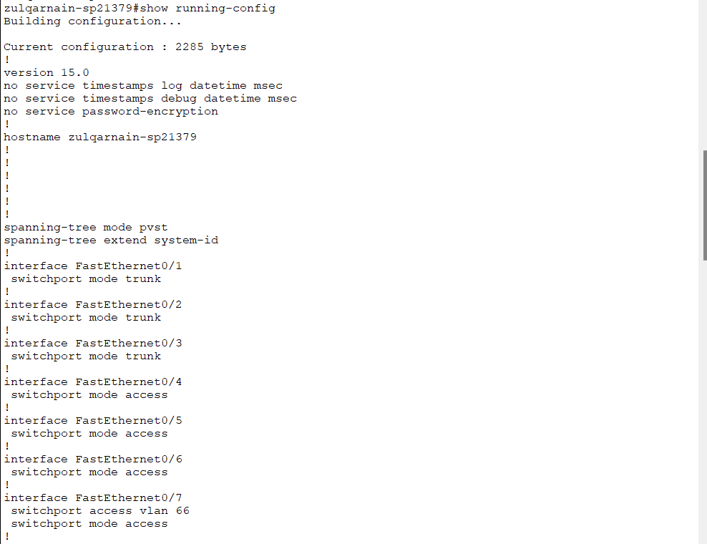
- Switch 2 Running Config
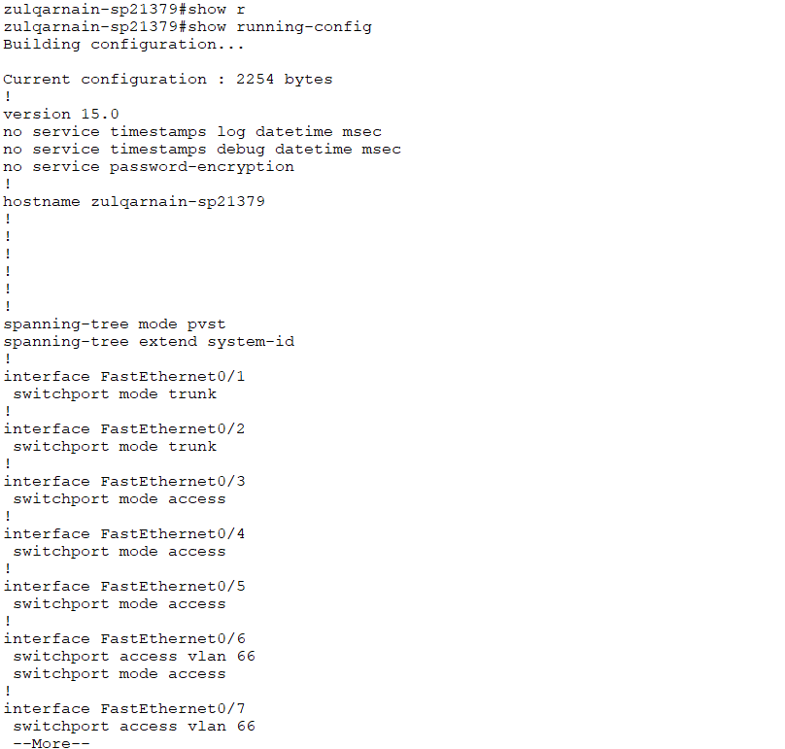
- Switch 3 Running Config

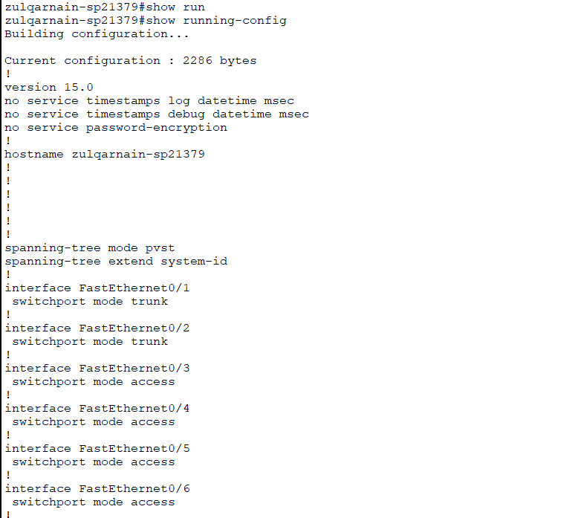

Section 1.2: Switch VLAN brief - Ports configuration [3 Marks]

Paste the VLANs ports distribution under each section.

- Switch 1 VLAN Ports
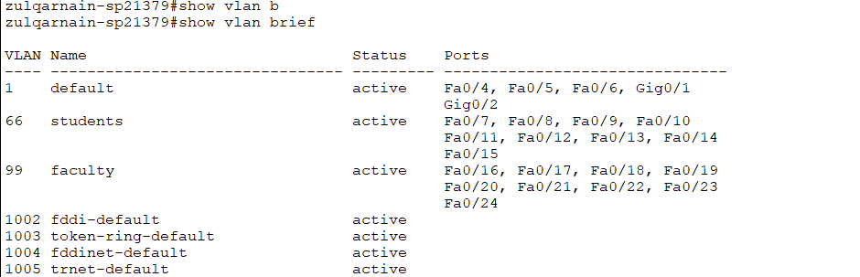
- Switch 2 VLAN Ports

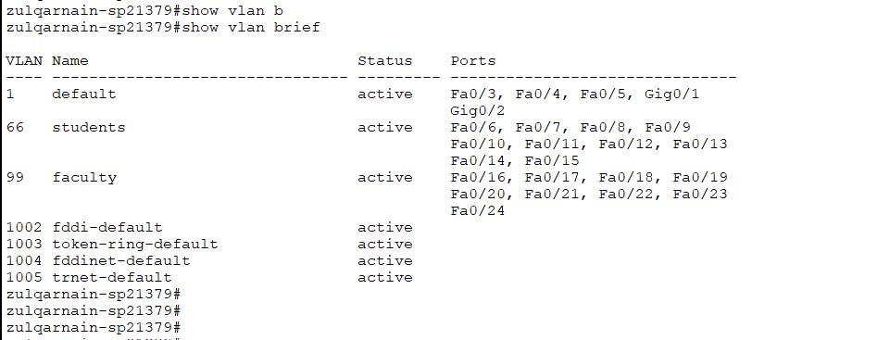
- Switch 3 VLAN Ports
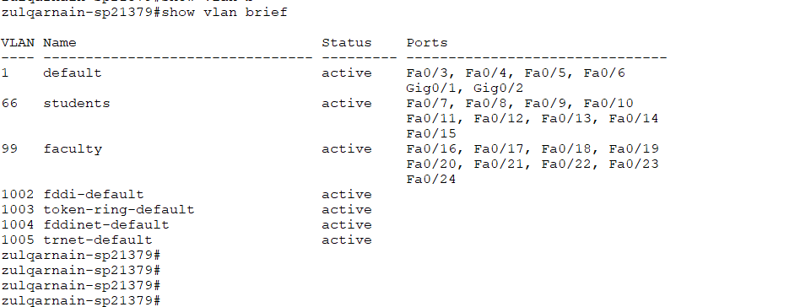
Section 1.3: Switch Root information [3 Marks]

Paste the spanning tree protocol information showing that Switch 1 is configured as a ROOT Switch.

- Switch 1 Root Switch
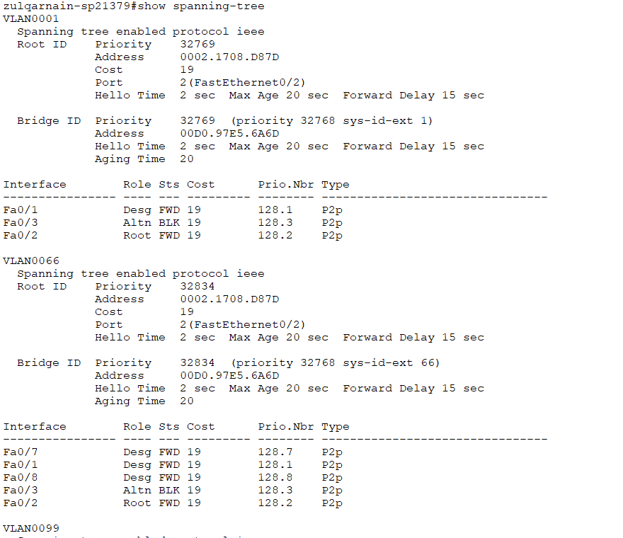
Section 1.4: DHCP Server [2 Marks]

Paste the DHCP configuration figures of each DHCP under the desired heading.

- VLAN666-DHCP

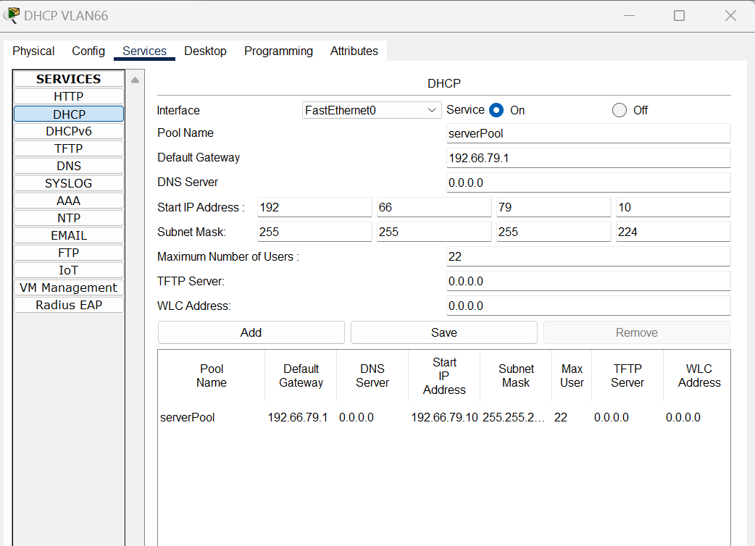

- VLAN999-DHCP

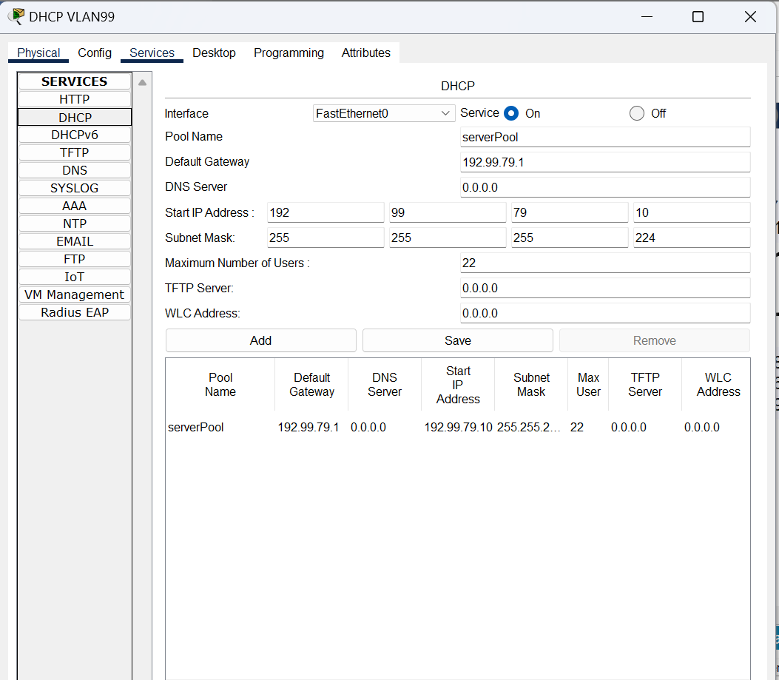
Section 1.5: DHCP working [2 Marks]

Show a PC has received an IP address from its corresponding DHCP servers.
- PC of VLAN666
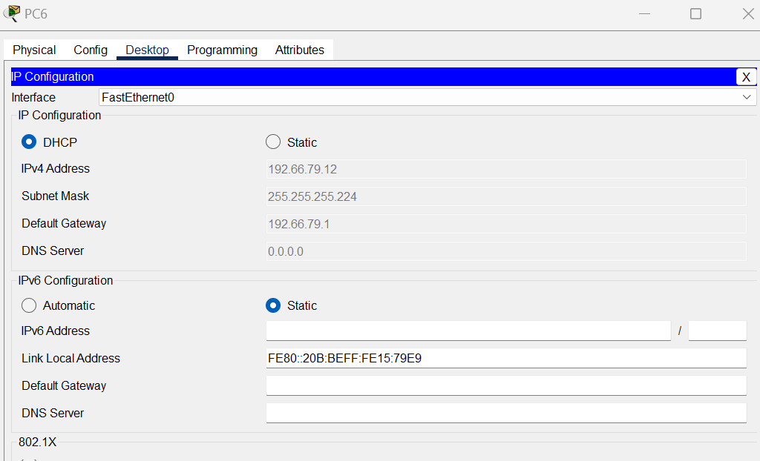
- PC of VLAN999
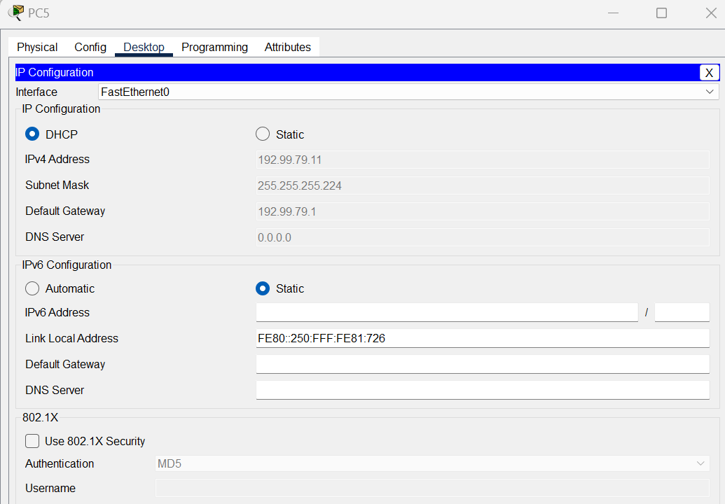
Section 1.6: Inter-VLAN-Routing – Pinging VLANs [3 Marks]

Show a PC belonging to VLAN 666 PING to PC of VLAN999.
- VLAN666 PC PING VLAN999
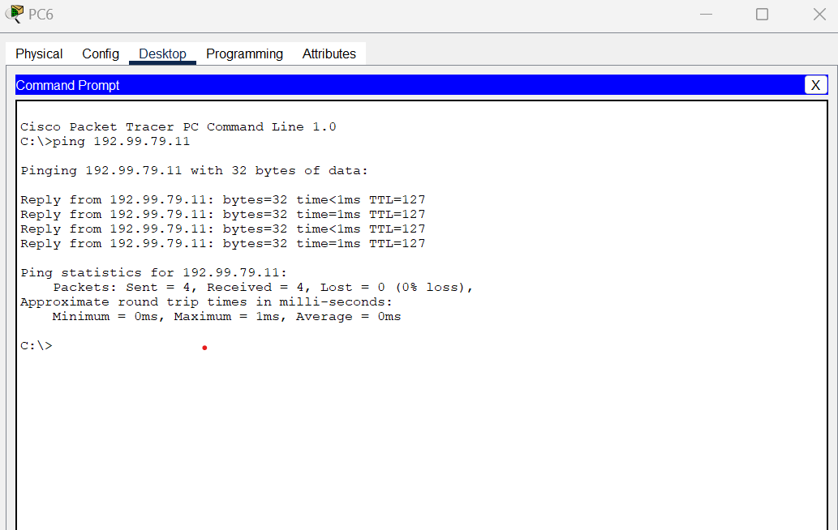
- VLAN666 PC PING its Gaetway
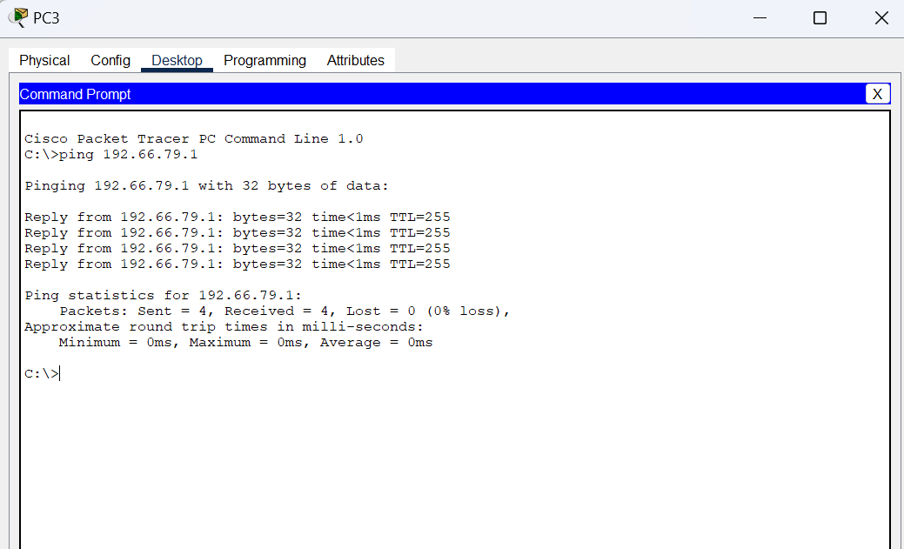
- VLAN999 PC PING VLAN666
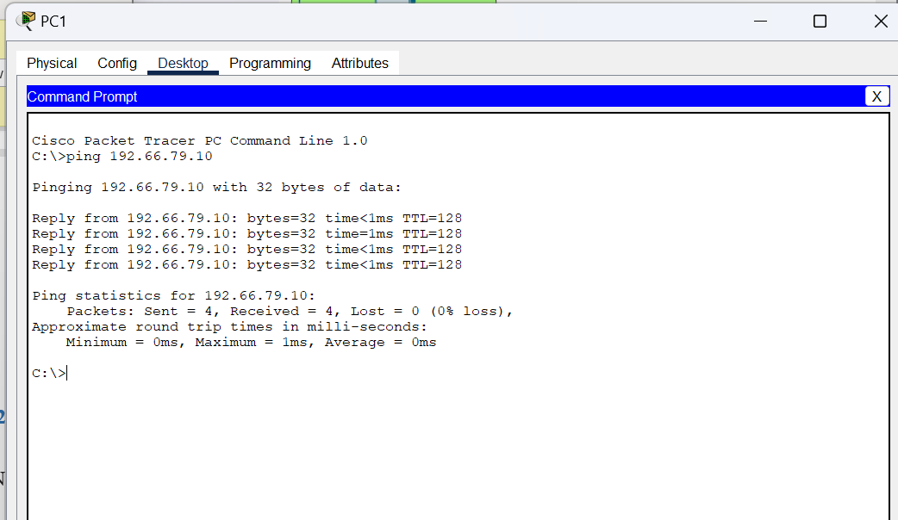

- VLAN999 PC PING its Gaetway
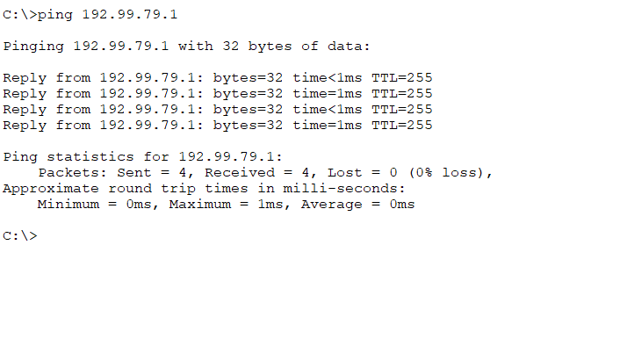
Section 1.7: Router on the stick – Lahore Router – Routing Table [2 Marks]

Show the IP Route of Lahore Router highlighting the 802.1q protocol for all VLANs. Provide description of the interface as well, for convenience.
- Lahore Router – Routing Table
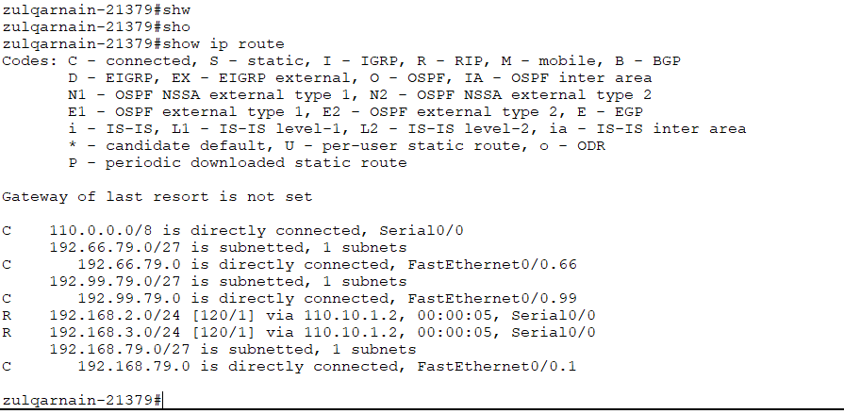
Section 1.8: Router on the stick – Lahore Router – Routing Table [2 Marks]

Show the IP Route of Lahore Router highlighting the 802.1q protocol for all VLANs. Provide description of each interface as well, for convenience.
- Lahore Router – Routing Table


Section 2: WAN [10 Marks]

Section 2.1: Routing Running Configuration of ALL Routers [3 Marks]

Once the Routers are configured, paste the Figure of each designated Router’s running-configuration under each section.

NOTE: Each Router should have MOTD and Name as defined in Q1 bullet 4.

- Router Lahore Running Config
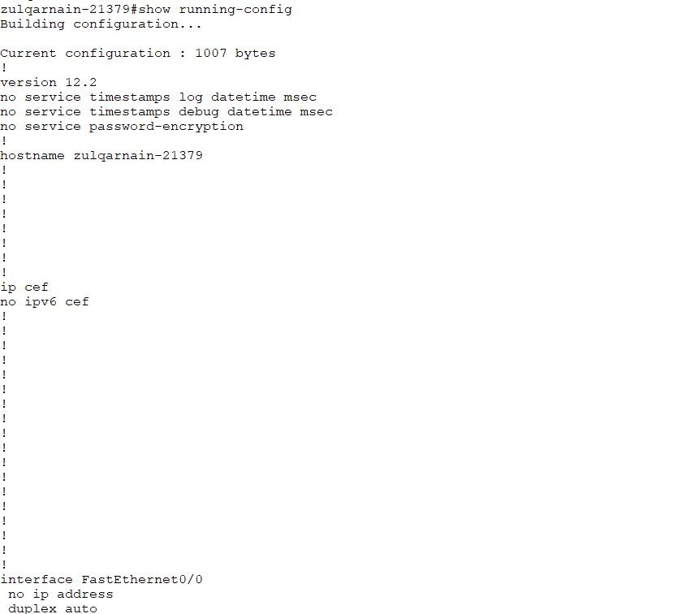
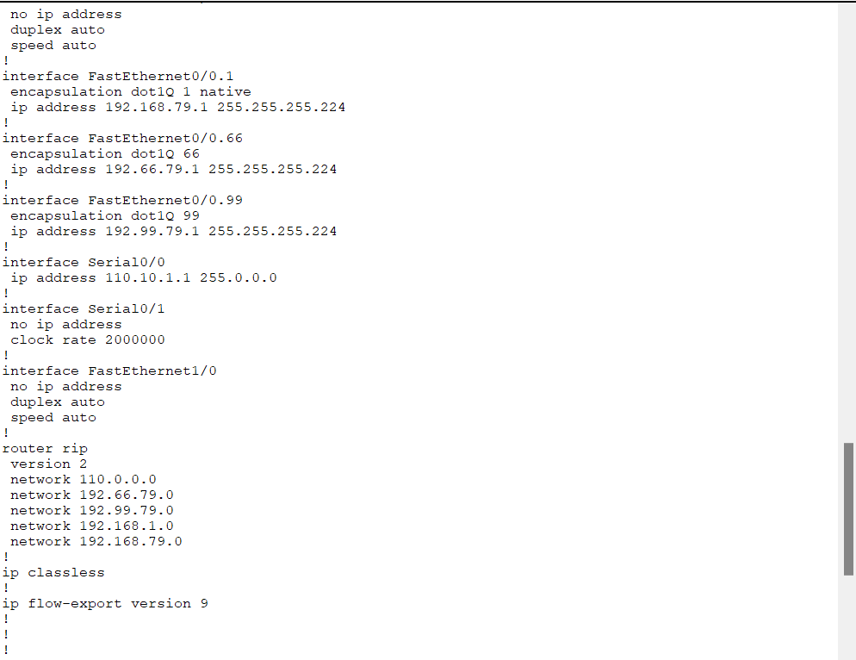
- Router PTCL Running Config
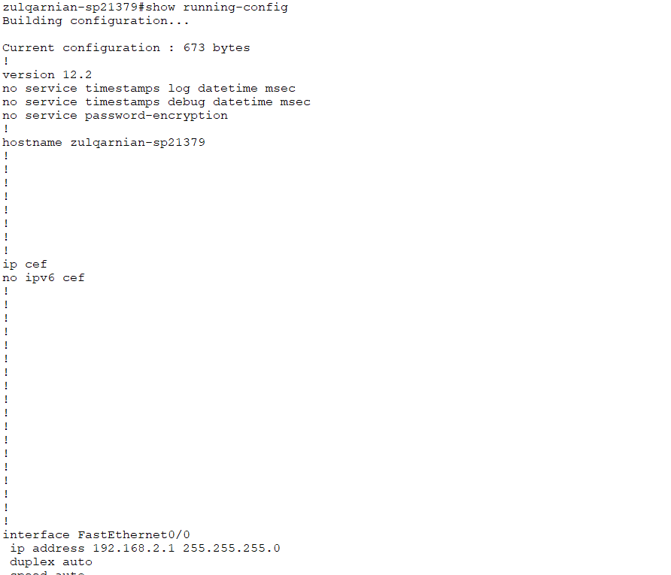
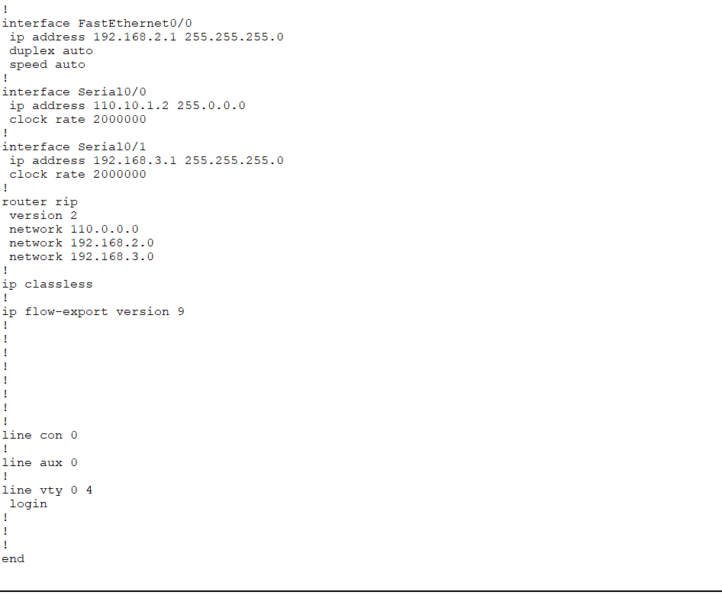
- Router HQISB Running Config
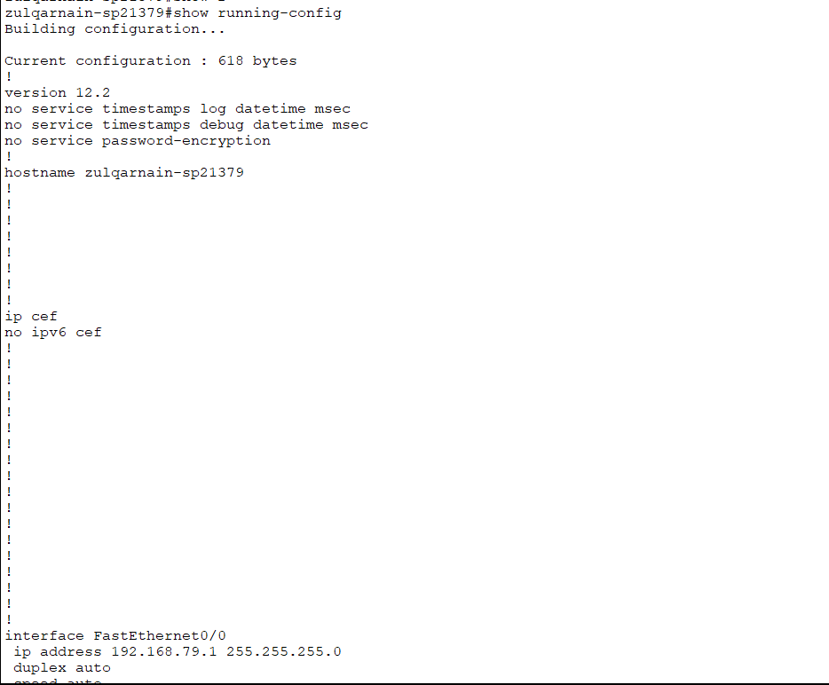
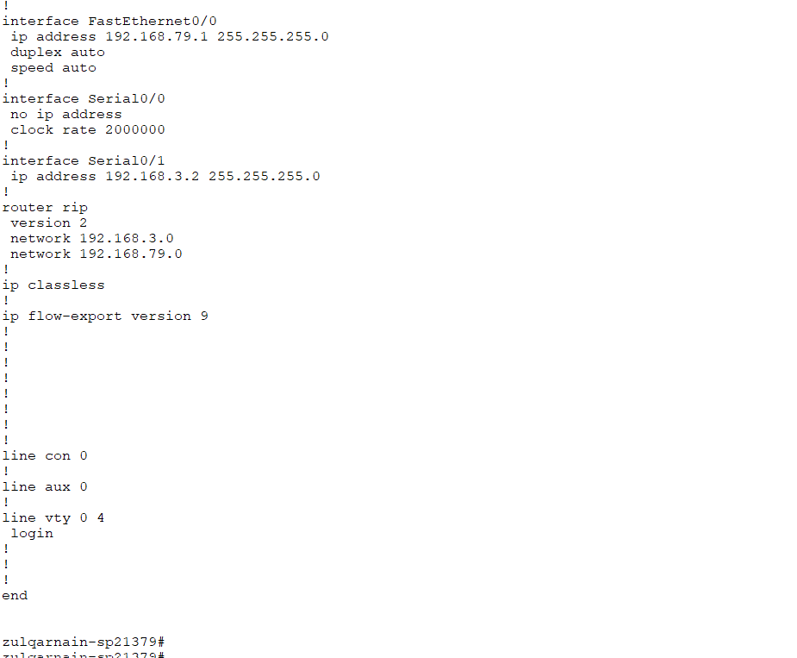

Section 2.2: Routers IP Route [3 Marks]

Once the Routers are configured, paste the Figures of each designated Router’s IP Route under each section.

- Router Lahore IP Route
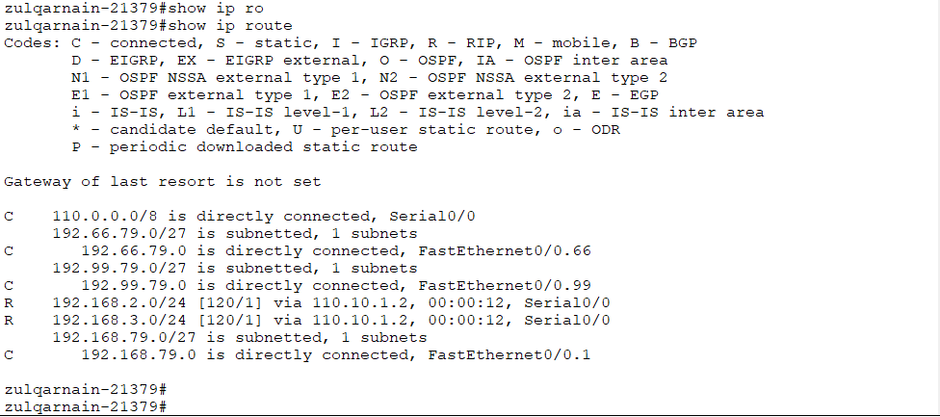
- Router PTCL IP Route
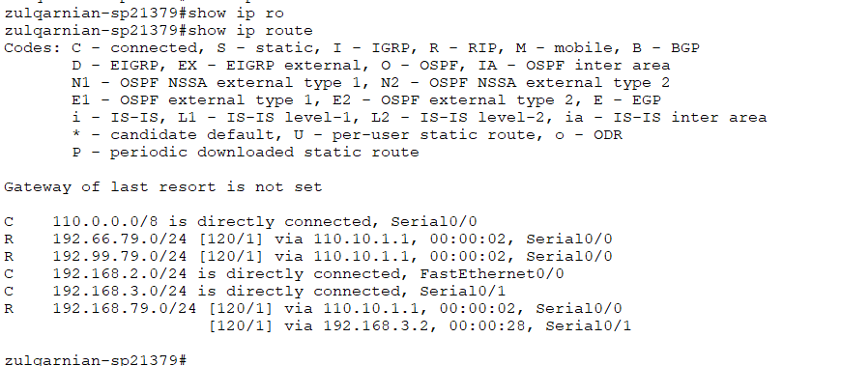
- Router HQISB IP Route
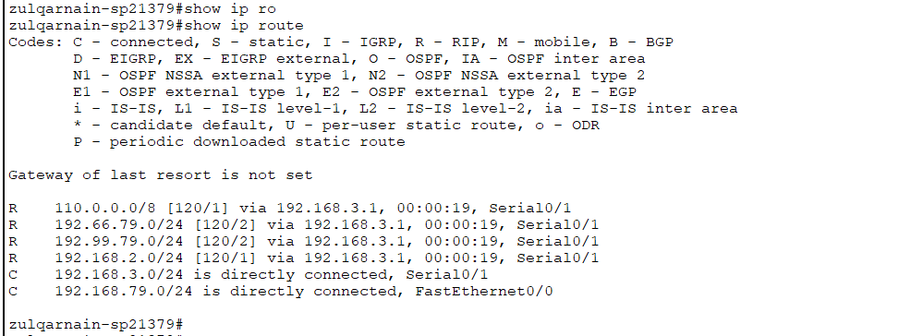
Section 2.3: DNS Configuration [4 Marks]

Once the DNS is configured, paste the Figures showing the entries of the switch and routers against their designated IP addresses, under the section.

- DNS Configuration

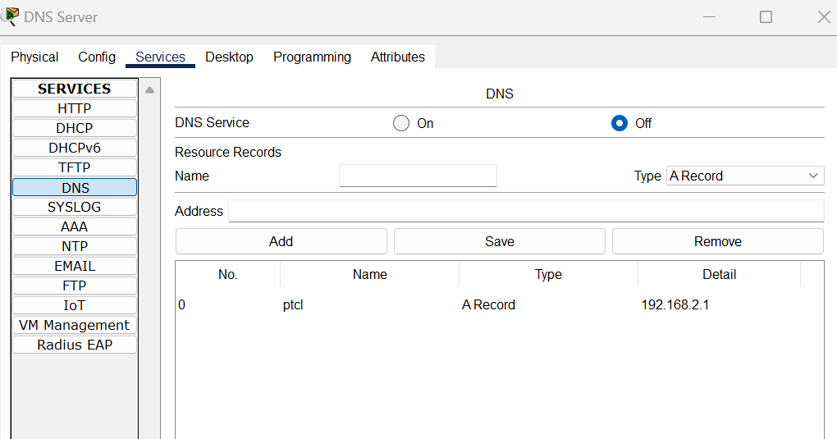

Section 2: Testing Network Connectivity [16 Marks]

Section 3.1: Testing the connectivity from PC0 [5 Marks]

Paste the Figure showing Ping information of the Following

- PC0 to PC4 test
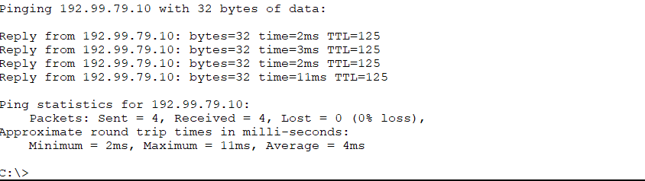
- PC0 to PC1 test
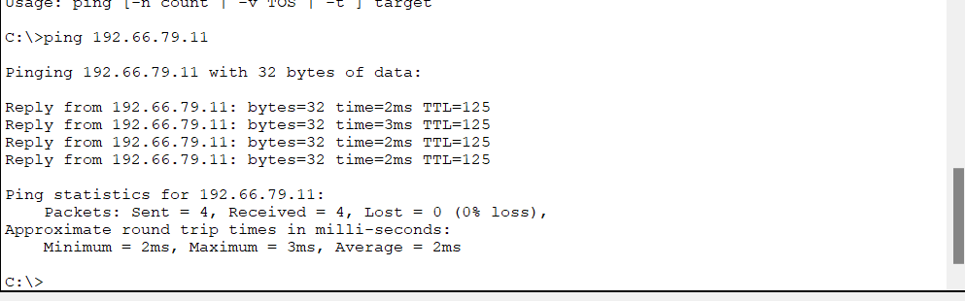

Section 3.2: Testing the connectivity from PC1 [5 Marks]

Paste the Figure showing Ping information of the Following PCs

- PC1 to PC4 test
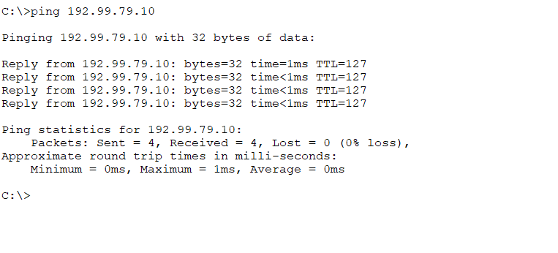
- PC1 to VLAN999 DHCP Server test
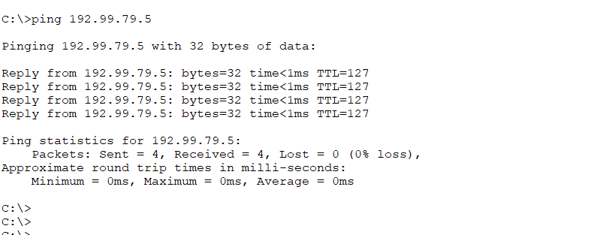
- PC1 to DNS Server
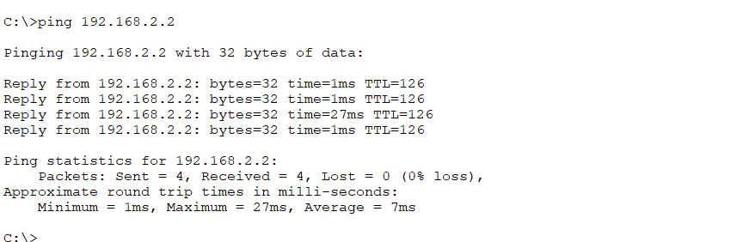
Section 3.3: Telnet to the Switch [6 Marks]

Once the Passwords are set Paste the Figure showing Telnet to of the designated Switches under the following headings.

- PC5 to Switch 1
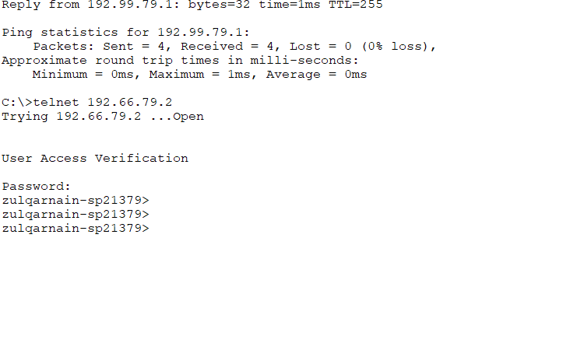
- PC1 to Switch 2
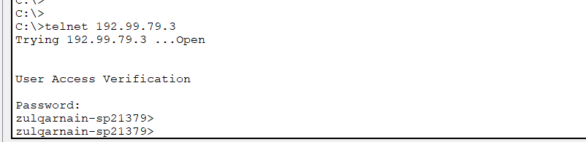

- PC3 to Switch 3



***********THE END************

